Pokhara University

Level: Bachelor | Semester – Spring | Year : 2007
Programme: BE |  | Full Marks: 100
Course: Database System |  | Time : 3hrs.

Candidates are required to give their answers in their own words as far as practicable.
The figures in the margin indicate full marks.

Attempt all the questions.

 | - What are the major components of database manager? Explain briefly.  - A database is to be designed for a college to monitor students’ progress throughout their course of study. The students are reading for a degree (such as BE, ME, etc.) within the framework of the modular system. The college provides a number of modules, each being characterised by its code, title, credit value, module leader, teaching staff and the department they come from. A module is co-ordinated by a module leader who shares teaching duties with one or more lecturers. A lecturer may teach (and be a module leader for) more than one module. Students are free to choose any module they wish but the following rules must be observed: some modules require pre-requisites modules and some degree programmes have compulsory modules. The database is also to contain some information about students including their numbers, names, addresses, degrees they read for, and their past performance. Draw ER Diagram. | 5  10
 | Consider the following sample database.  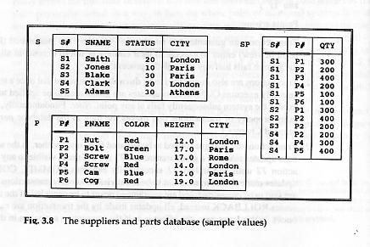  - Give an expression in relational algebra for each of the following:  - Get supplier names for suppliers who supply at least one red part  - Get supplier names for suppliers who supply all parts  - Give an expression in SQL for each of the following:  - Insert a new supplier S10 into table S. The name and city are Smith and New York respectively; the status is not yet known.  - For each part supplied, get the part number and the total shipment quantity.  - Create a view such that it consists of S#, STATUS, and CITY with STATUS not less than 15. | 15
 | - Differentiate between Tuple Relational Calculus. and Domain Relational Calculus.  - What is embedded SQL? Discuss different parts of embedded SQL and their feature. | 7  8
 | - What do you mean by candidate key? Differentiate between primary key and foreign key. Recognize relevant keys for the database given in Q.No. 2.  - What are integrity constraints? Describe the various methods to ensure integrity constraints. | 8  7
 | - Describe the importance of data normalization in database design. Also, illustrate the process of normalization (up to 3NF) with appropriate example.  - Draw a state diagram, and discuss the typical states that a transaction goes through during execution. | 8  7
 | - Define scheduler, Serializability and locking in concurrency control. Explain each of them in brief.  - Show that authorization systems based on Bell-La Padula model is safe. | 9  6
 | Write short notes on (Any Two):  - Client Server Architecture  - Functional dependency  - Deadlock prevention  - Snapshots | 2×5

